19CSE401- COMPILER DESIGN EXP 1
BASIC LEX PROGRAMMS
AIM-> TO WRITE BASIC LEX PROGRAMMS IN UBUNTU AND COMPILE THEM IN THE TERMINAL

ANANTHARAJAN V B
CH.EN.U4CSE22004
CSE A

1) HELLO WORLD
CODE
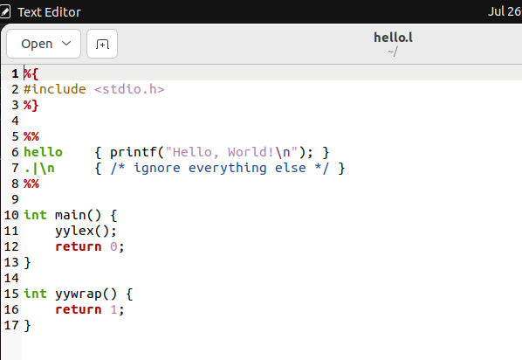
TERMINAL CODE AND OUTPUT
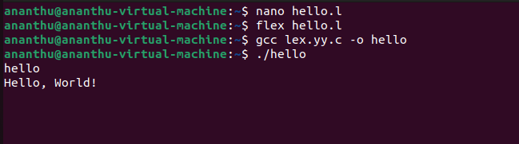

2) CHECK IF INPUT IS A DIGIT OR LETTER
CODE

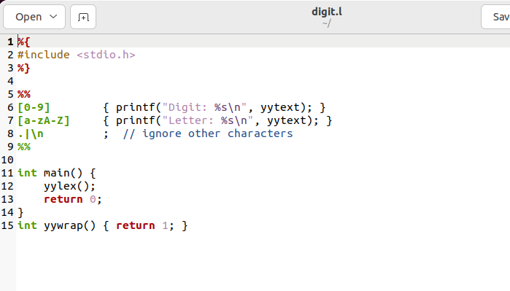
TERMINAL CODE AND OUTPUT
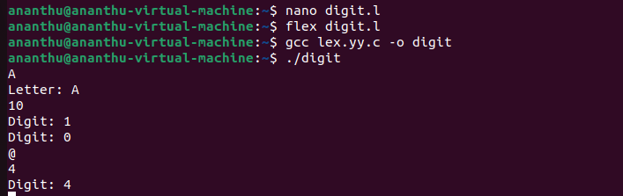
3) COUNT VOWELS

CODE
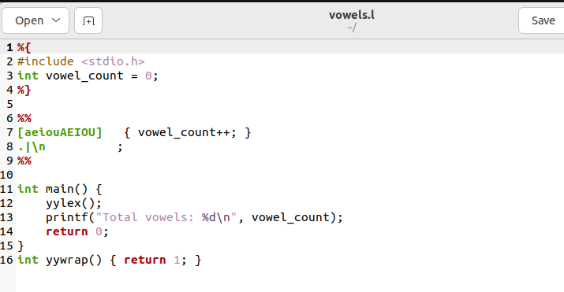

TERMINAL CODE AND OUTPUT

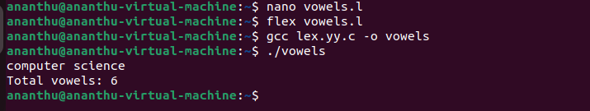
4) Identify Whitespaces (space, tab, newline)

CODE
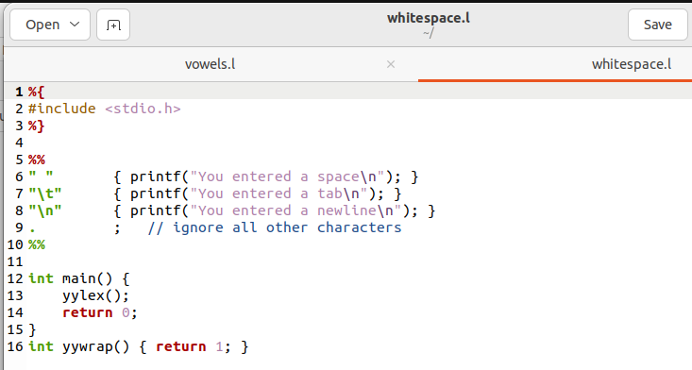

TERMINAL CODE AND OUTPUT
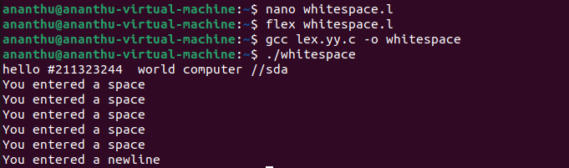
5) check Whether Input is Vowel or Consonant (Single letter)

CODE
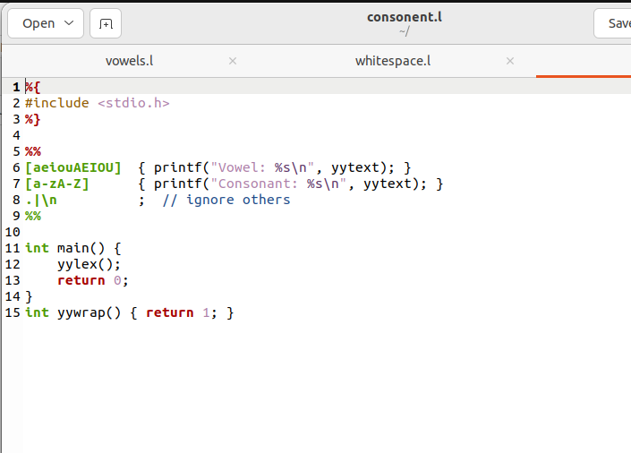

TERMINAL OUTPUT AND CODE

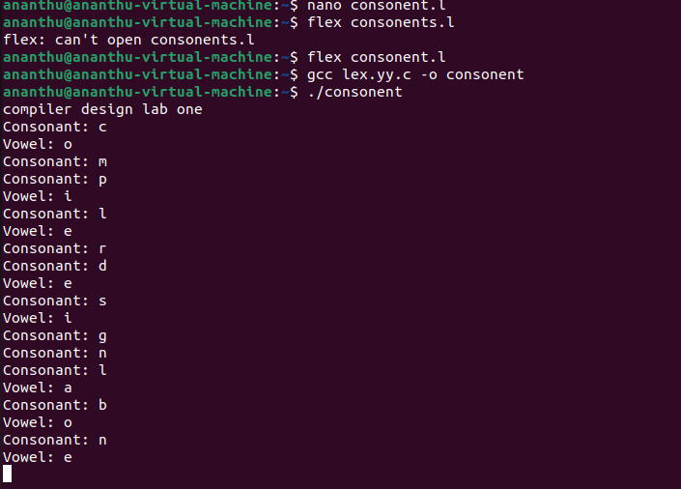
COMPILATION STEPS
1) Write your lux code in notepad and save it
ex) nano filename.l

2)Generate C code from the LEX file:
ex) flex filename.l

3)Compile the C code into an executable:
ex) gcc lex.yy.c -o outputname

4)Run the executable:
ex) ./outputname

5)View output and results based on your LEX rules
RESULT-> THE FOLLOWING CODES WERE COMPILED USING LUX AND RUN IN TERMINAL AND OUTPUTS WERE OBTAINED

